**FASTEST FINGER PRESS QUIZ BUZZER**

**ABSTRACT**

A set of 8 switches are interfaced to D-type flip flop working as priority encoder. While number of switches is pressed at same time, it takes the first switch pressed into consideration and generates a buzzer sound along with the indication of the switch pressed.

This circuit includes 8 numbers of push buttons which are fed to a D-type flip-flop. This flip-flop generates o/p signal which is fed to a transistor, making the corresponding LED to switch ON and also generates a buzzer sound.

Further the project can be enhanced by using a display to indicate the order in which switches are pressed.

**BLOCK DIAGRAM:**

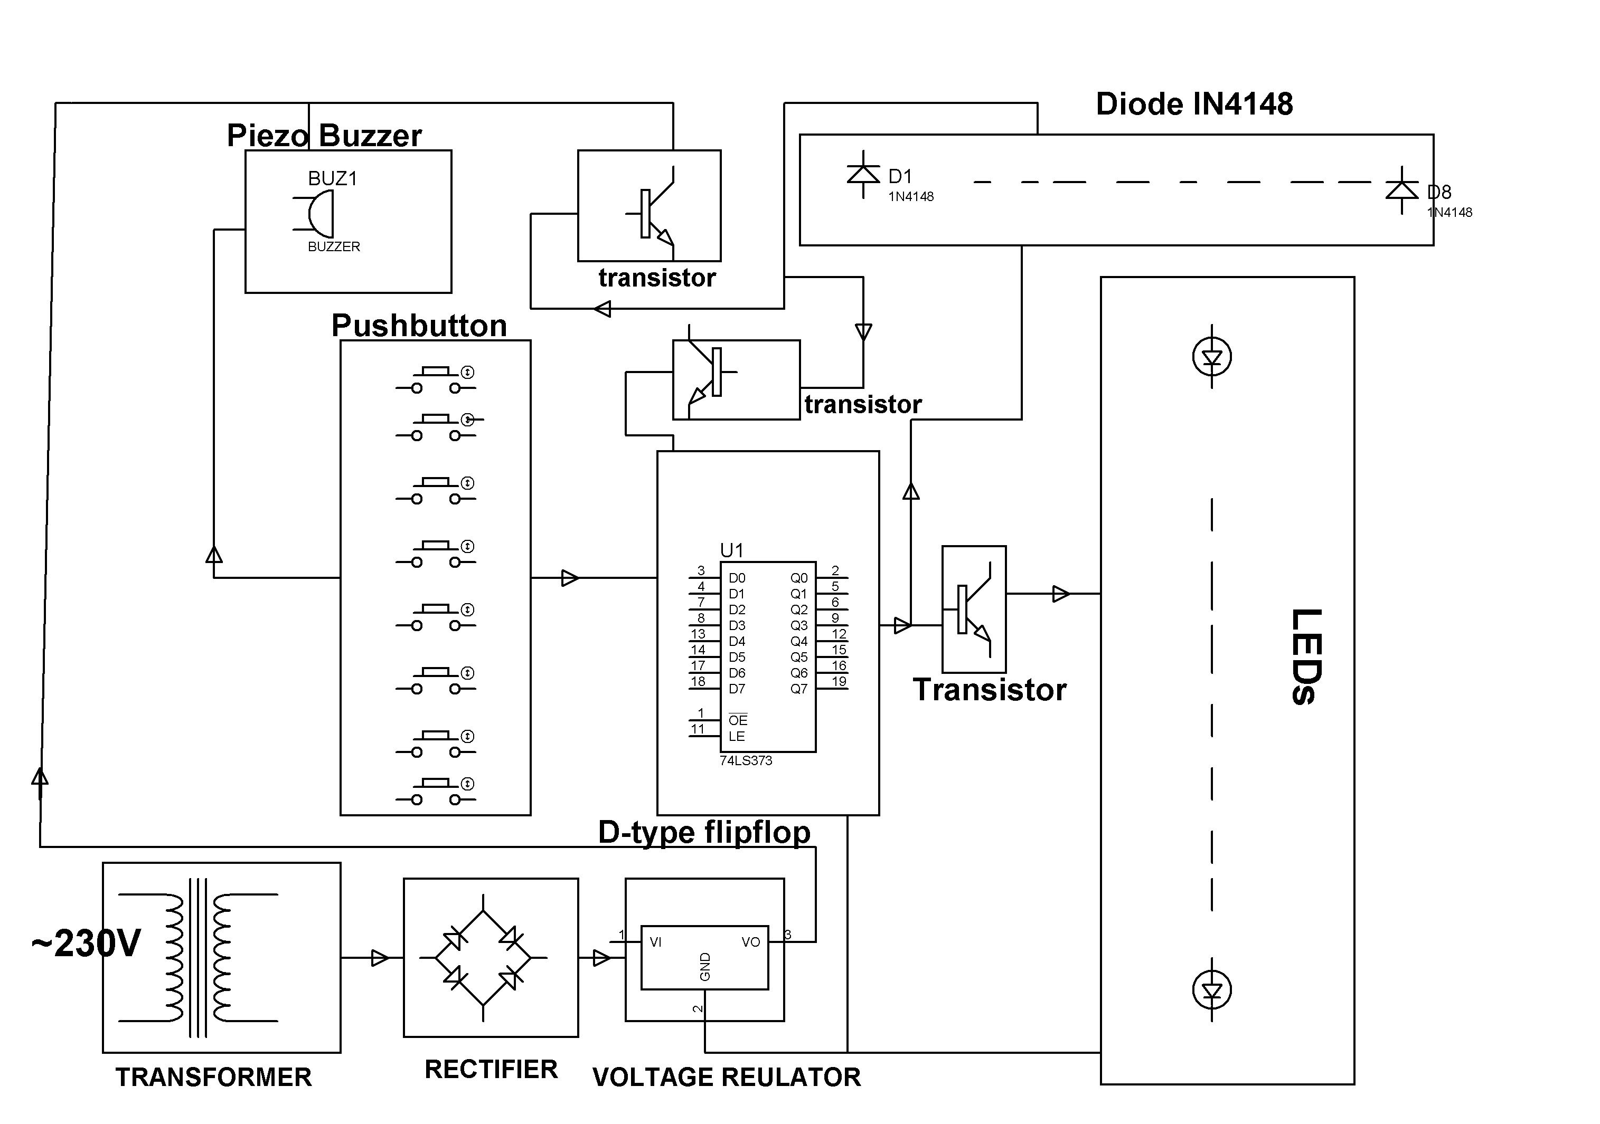

**HARDWARE REQUIREMENTS:**

Transformer, Diodes, Capacitors, Resistors, LED’S, D flip flop, LEDs, Transistor, Push Button, Buzzer.